**RedHat System Administration**



**Shenouda Nabil Lamei**

**Bash Script Project**

**Supervised by.**

**Eng / Romany Nageh**

**Overview**

This collection of Bash utilities (or a single multi-mode script with subcommands) automates common Linux user & group admin tasks:

* user add / del / mod / list
* group add / del / mod / list
* change password (securely or interactive)
* lock / unlock account (disable/enable login)

They wrap standard system tools (useradd, userdel, usermod, passwd, chpasswd, groupadd, groupdel, groupmod, getent, passwd -l/-u) and add validation, logging, and safe behavior.

**What each operation does (short)**

* **Add user**: creates account, optional home dir, shell, initial groups, expiration, UID. Uses useradd (and passwd or chpasswd to set password).
* **Delete user**: removes account; optionally remove home and mail spool (userdel -r).
* **Modify user**: change shell, home, primary/secondary groups, expiry, UID/GID, etc. Uses usermod.
* **List users**: list system users (via /etc/passwd or getent passwd) and filter by UID range if needed.
* **Add group**: create a group (groupadd).
* **Delete group**: remove group (groupdel) — ensure no critical members remain.
* **Modify group**: rename or change GID (groupmod).
* **List groups**: show groups (getent group).
* **Change password**: interactive passwd username (recommended) or programmatic chpasswd (careful — plaintext).
* **Lock/Unlock**: passwd -l username locks (prefixes ! in /etc/shadow), passwd -u username unlocks. usermod -L/-U do similar.

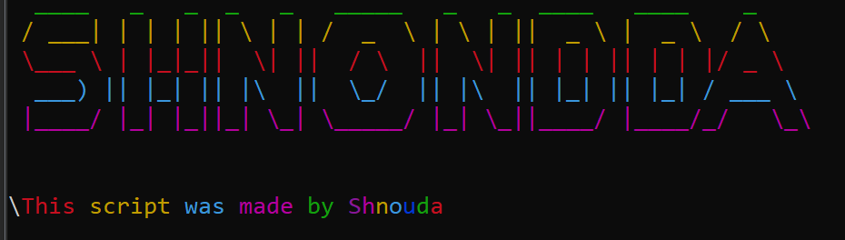

1- code for main project.

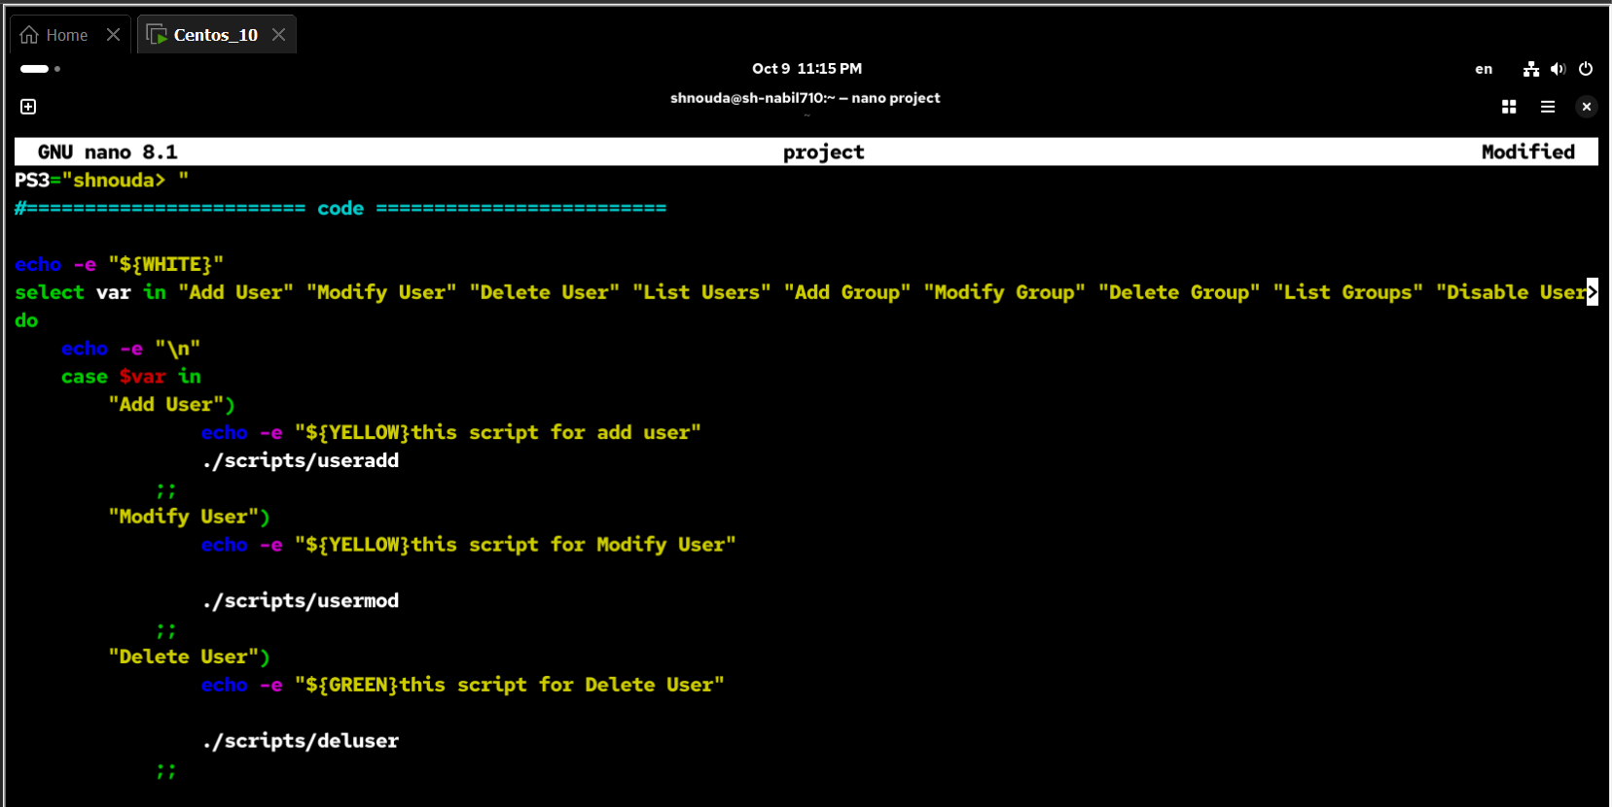

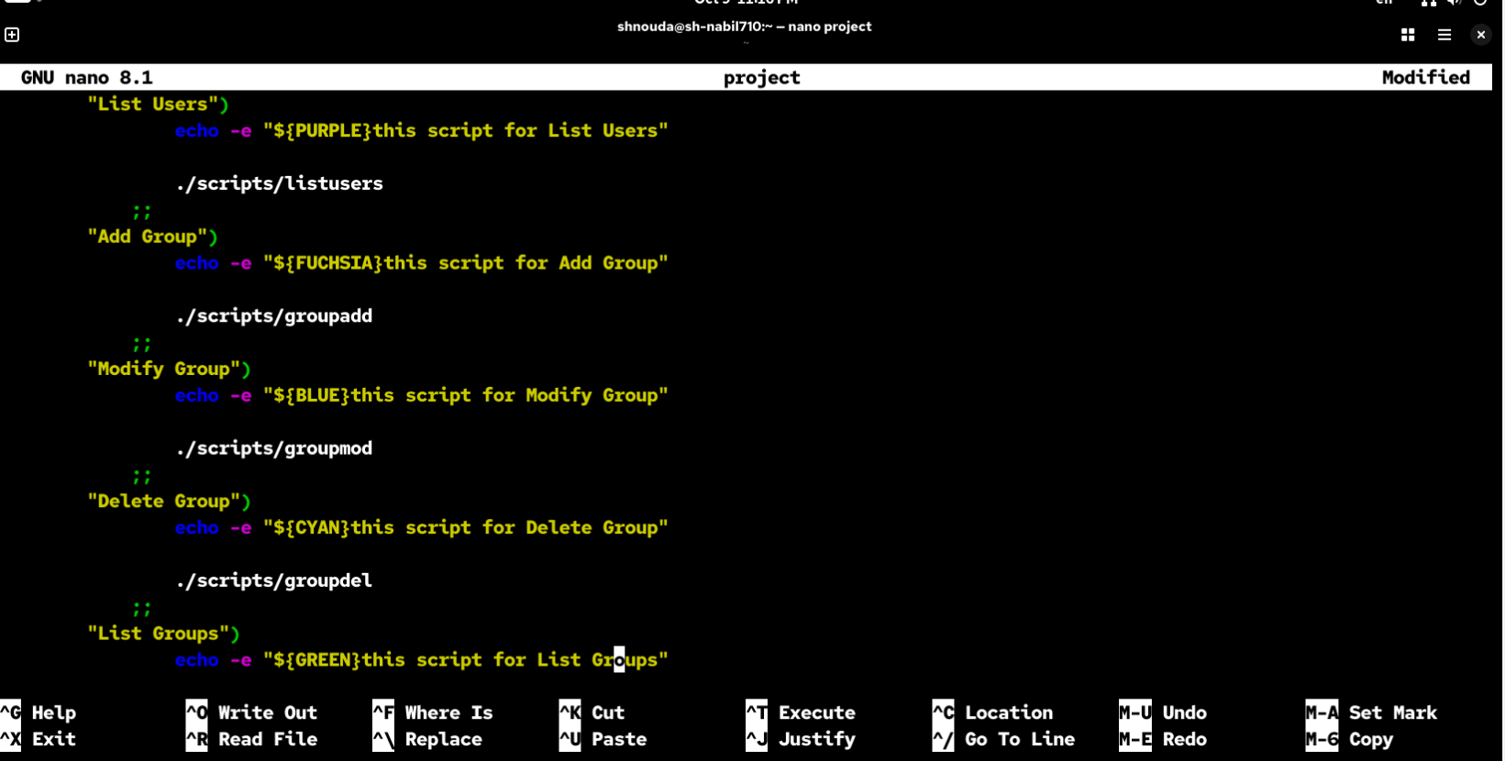

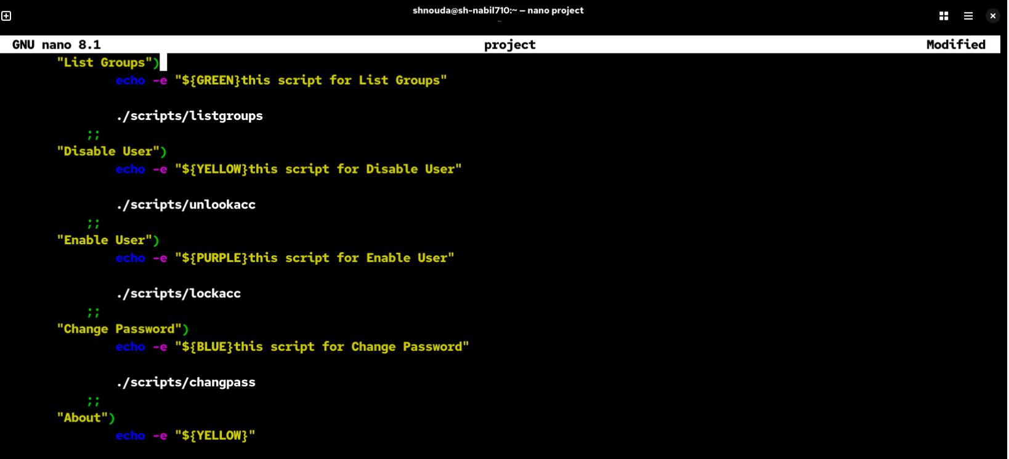

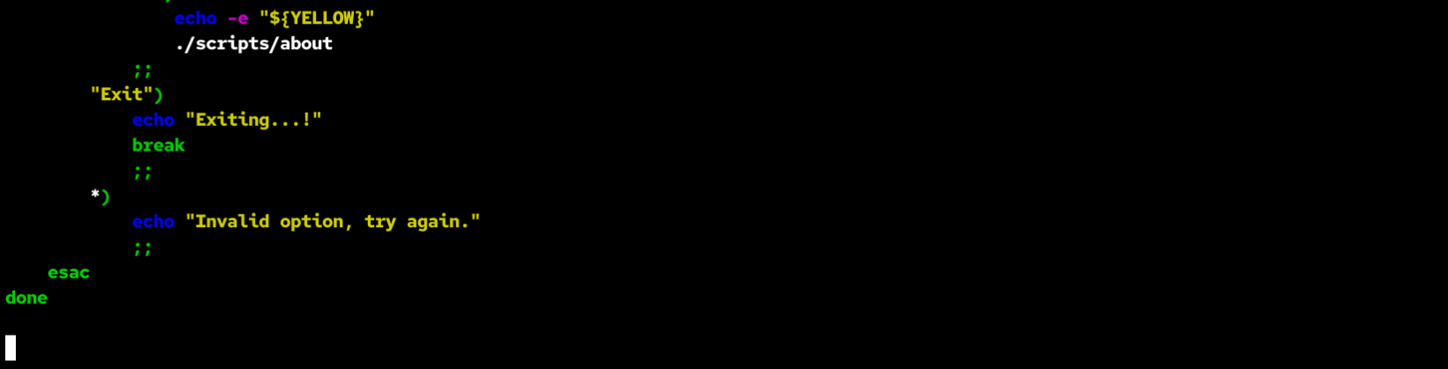

**Project Preview**

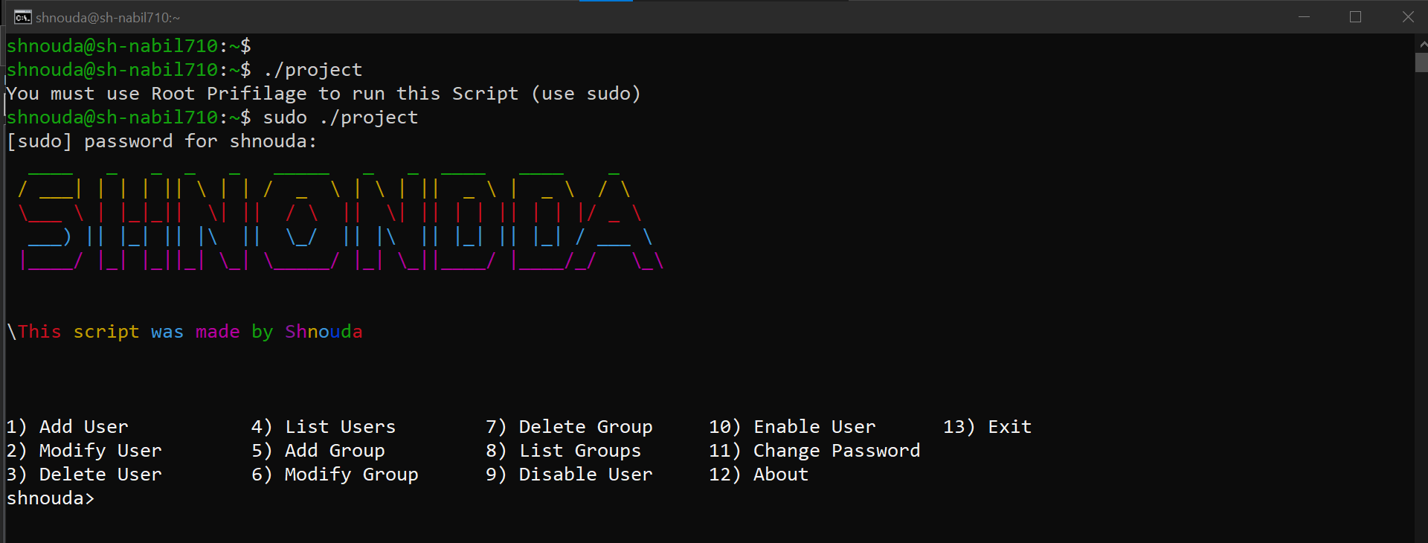

1- User add

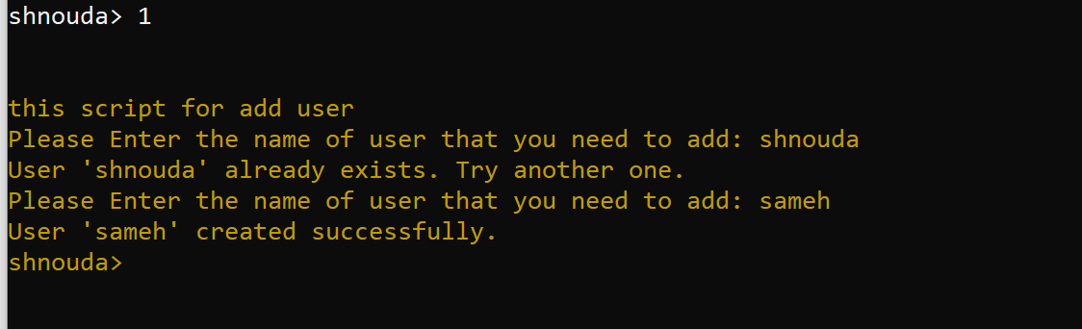

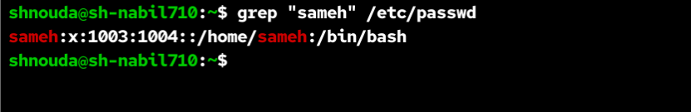

2- User mod

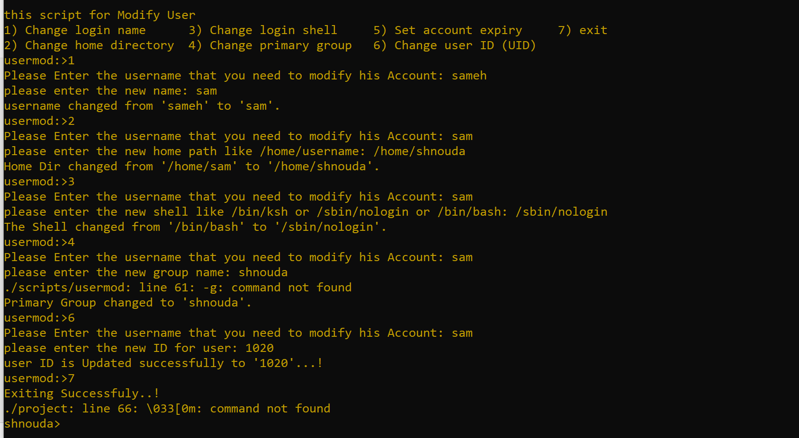

3- delete user

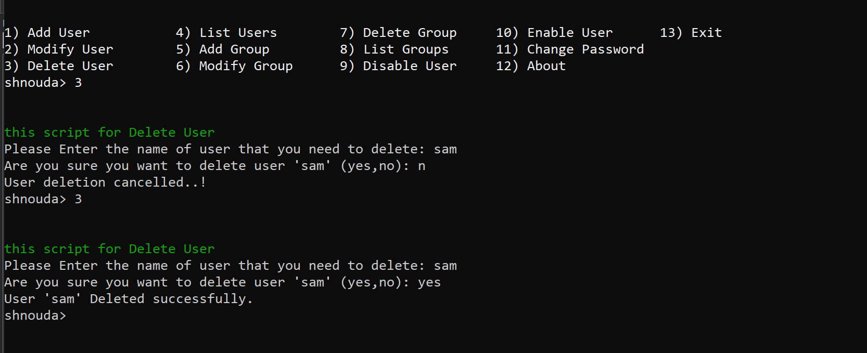

4- List users

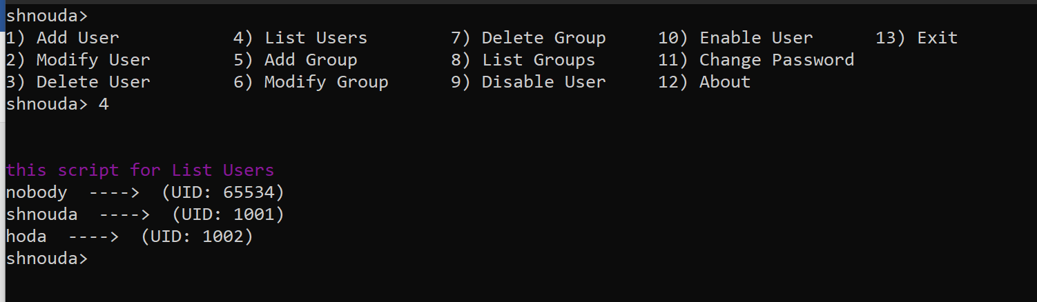

5- Group add

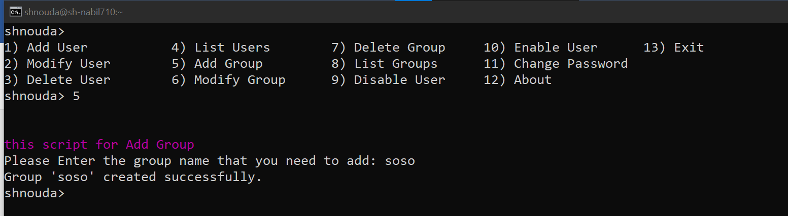

6- Group Mod

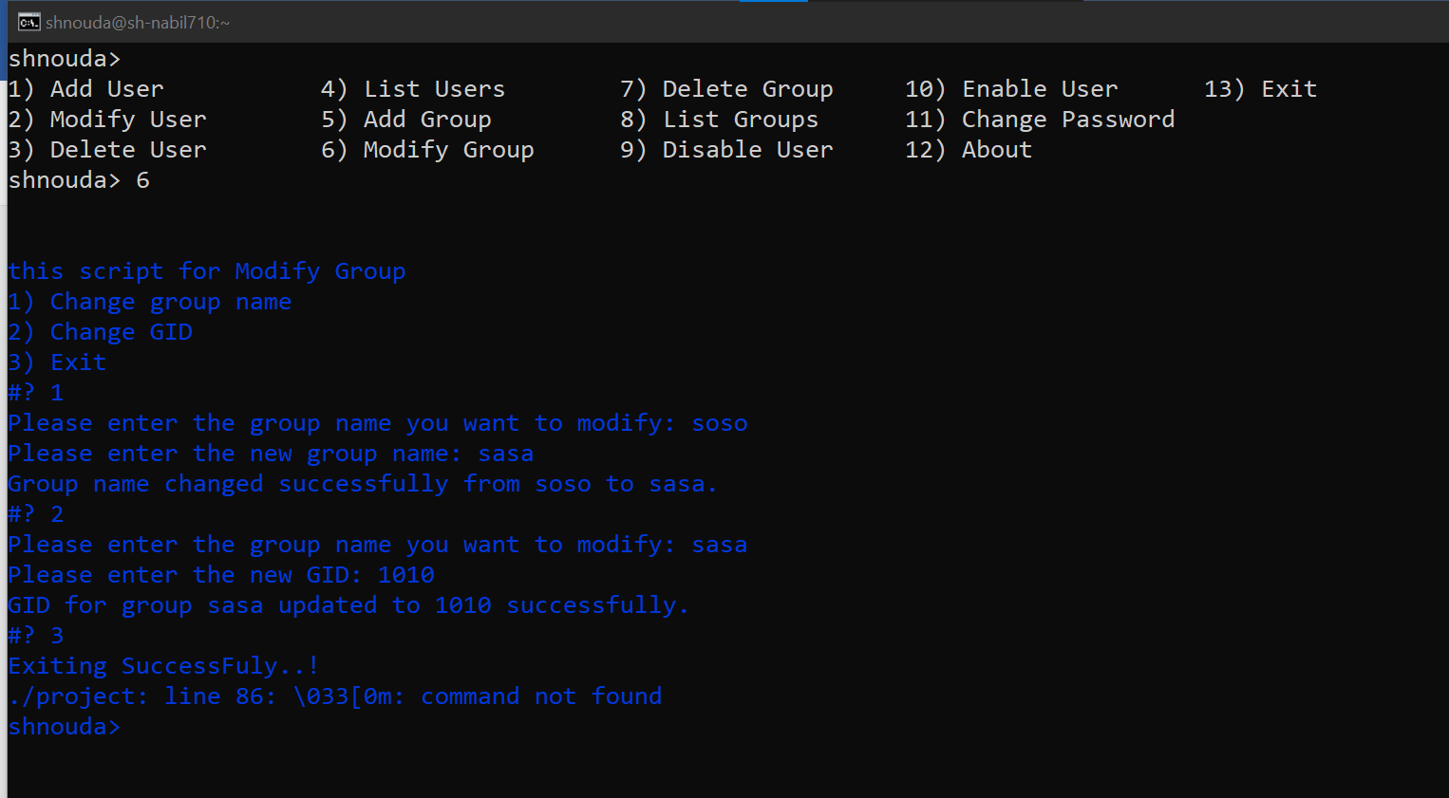

7- Delete Group

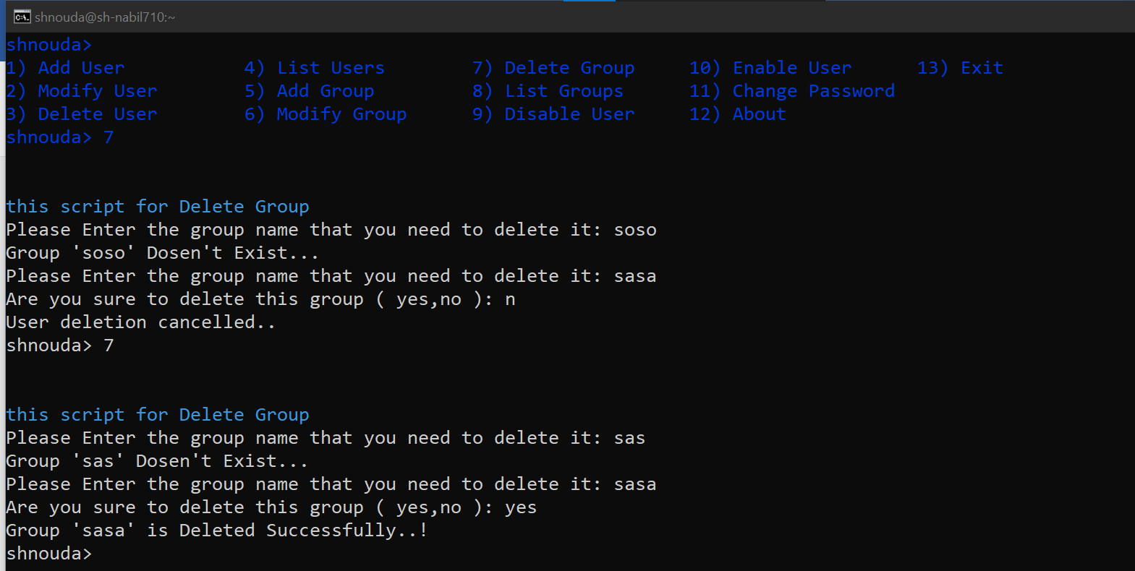

8- List groups

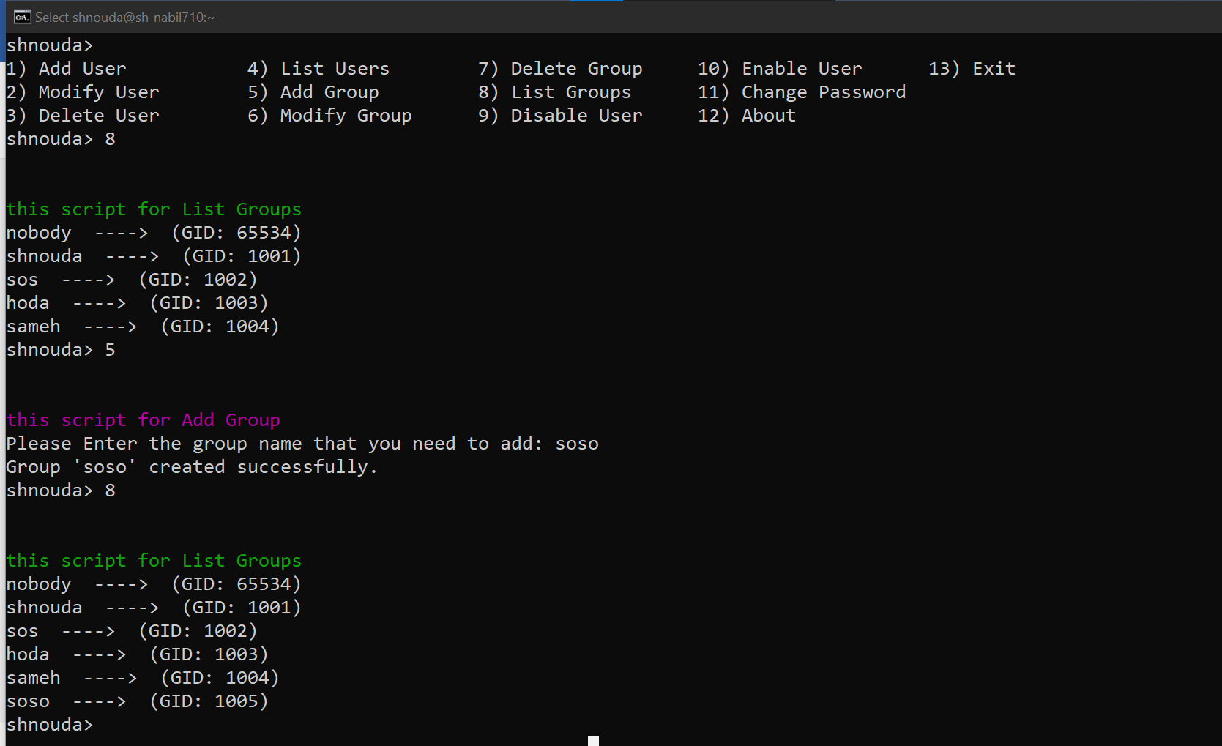

9- Disable user(Lock Account)

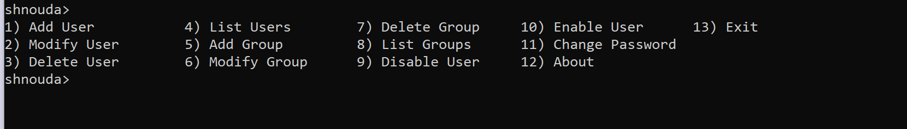

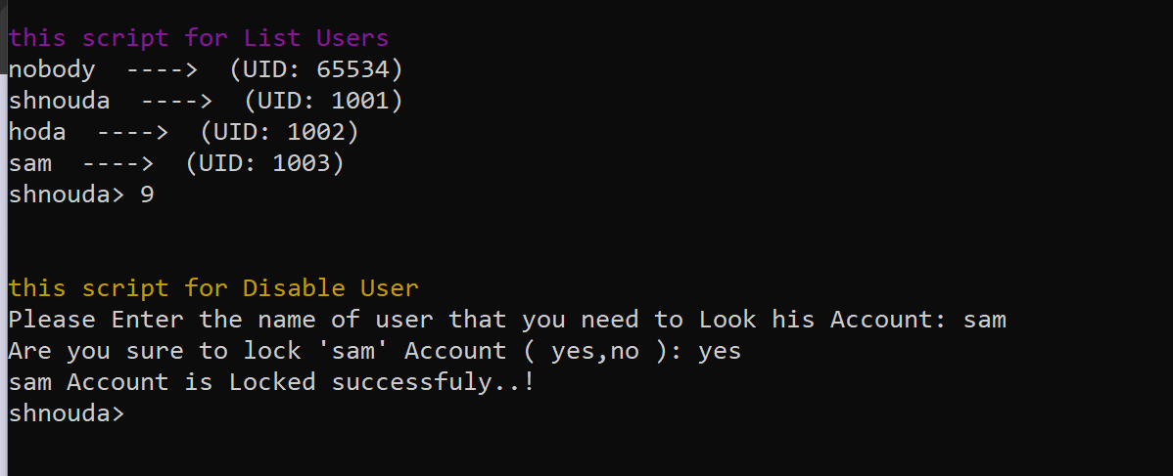

10- Enable User Account

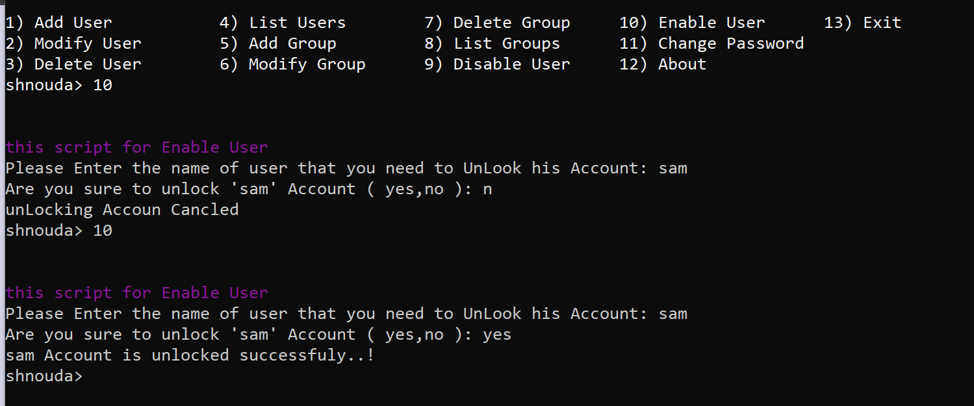

11- Change password

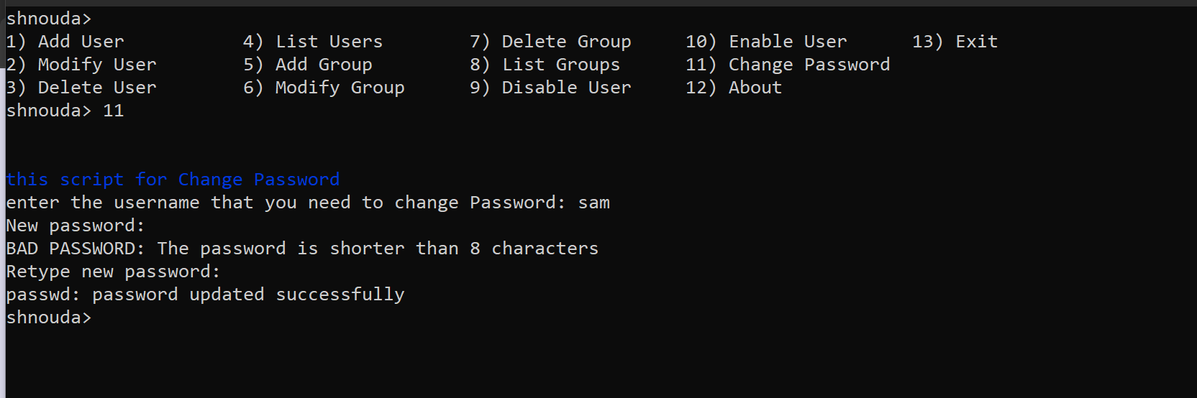

12- About

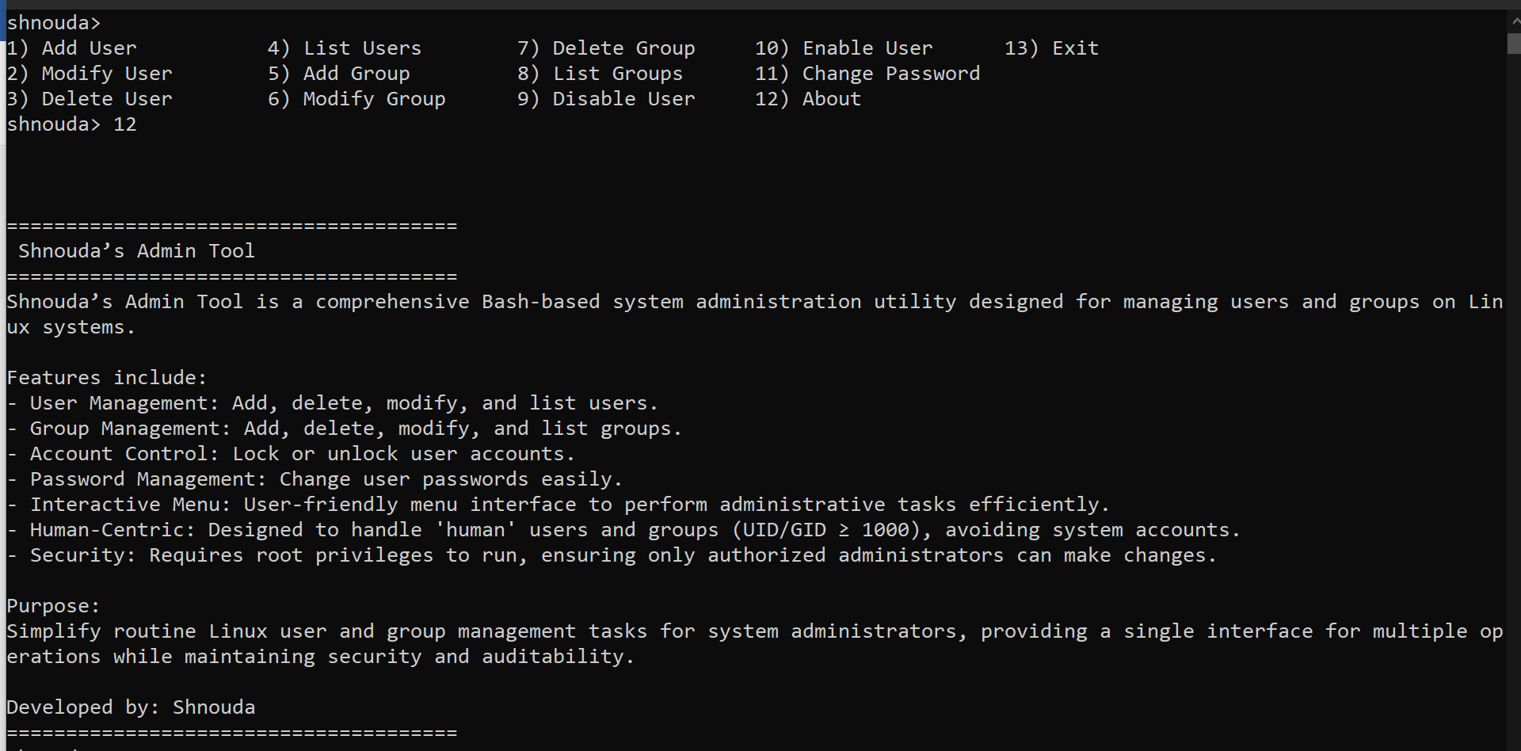

13- Exiting

